Coconut Cay
Seat 3: Troy Jones - (C.
Seat 1: Clarence Stronq Ill - (V.C.
Seat 4: Marvin Cordero - (A.S.

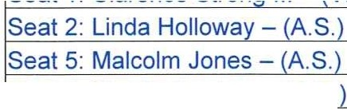

Community Development District
Special Meeting Agenda

Tuesday
September 28, 2021 3:00p.m.
1031 Ives Dairy Rd, Suite 228, Miami, FL https://global.gotomeeting.com/join/570001245
+1 (872) 240-3412; Access Code: 570-001-245

- Oath of Office for Mr. Malcolm S. Jones

- Roll Call

- Audience Comments (Related to Right to Speak Statute Changes - Public Comment Limited to 3 Minutes)

- Approval of Minutes of the August 18, 2021 Meeting

- Ranking of Engineering Firm Proposals

- Approval of Agreement for Project Engineering Services

- Approval of Construction Funding Agreement with Coconut Cay Homeowners Association, Inc.

- Staff Reports
  - Attorney

  - Engineer

  - Manager
    - Discussion of Financial Disclosure Report from the Commission on Ethics and Reminder to File Annual Form

- Financial Reports
  - Approval of Check Run Summary
  - Combined Balance Sheet 10.Supervisors Requests and Audience Comments 11.Adjournment
Meetings are open to the public and may be continued to a time, date and place certain. For more information regarding this CDD please visit the website: http://www.coconutcaycdd.com

