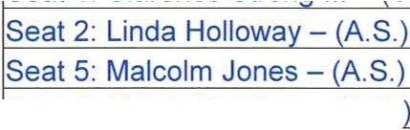

Coconut Cay
!Seat 3: Troy Jones - (C.)
!Seat 1: Clarence Strong Ill - (V.C.)
!Seat 4: Marvin Cordero - (A.S.

Community Development District
Agenda

Wednesday April 20, 2022 3:00p.m.
City of Miami Gardens City Hall, the Community Room 18605 NW 27 Avenue, Miami Gardens, FL 33056
https://meet.goto.com/501325621
+1 (872) 240-3212; Access Code: 501-325-621

- Roll Call

- Audience Comments (Related to Right to Speak Statute Changes - Public Comment Limited to 3 Minutes)

- Approval of Minutes of the December 8, 2021 Meeting

- Consideration of Resolution #2022-01 Approving the Proposed Fiscal Year 2023 Budget and Setting the Public Hearing

- Consideration of Resolution #2022-02 Designating Alyssa Willson as Registered Agent

- Discussion of Procedures for the General Election

- Acceptance of Audit for Fiscal Year Ending September 30, 2021

- Approval of First Amendment to Construction Funding Agreement with Coconut Cay Homeowners Association, Inc.

- Staff Reports
  - Attorney

  - Engineer - Discussion/Updates on Stormwater Management Needs Analysis

  - Manager

- Financial Reports
  - Approval of Check Run Summary

  - Combined Balance Sheet

- Supervisors Requests and Audience Comments

- Adjournment
Meetings are open to the public and may be continued to a time, date and place certain. For more information regarding this CDD please visit the website: http://www.coconutcaycdd.com

