Coconut Cay
Seat 3: Trov Jones - (C.
Seat 1: Clarence Stronq Ill - (V.C.
Seat 4: Marvin Cordero - (A.S.

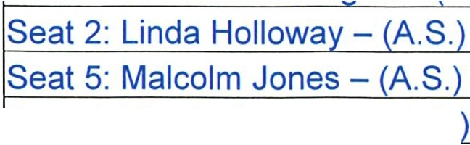

Community Development District
Agenda

Wednesday August 18, 2021
3:00 p.m.
1031 Ives Dairy Rd, Suite 228, Miami, FL https://global.gotomeeting.com/join/449493413
+1 (408) 650-3123; Access Code: 449-493-413

- Oath of Office for Ms. Linda H. Holloway and Mr. Malcolm S. Jones

- Roll Call

- Audience Comments (Related to Right to Speak Statute Changes - Public Comment Limited to 3 Minutes)

- Approval of Minutes of the April 21, 2021 Meeting

- Public Hearing to Adopt the Fiscal Year 2022 Budget
  - Motion to Open the Public Hearing

  - Public Comment and Discussion

  - Consideration of Resolution #2021-06 Annual Appropriation Resolution

  - Consideration of Resolution #2021-07 Levy of Non Ad Valorem Assessments

  - Motion to Close the Public Hearing

- Approval of Request for Qualifications for Project Engineering Services

- Staff Reports
  - Attorney

  - Engineer

  - Manager
    - Consideration of Proposed Fiscal Year 2022 Meeting Schedule

    - Discussion of Financial Disclosure Report from the Commission on Ethics and Reminder to File Annual Form

    - Number of Registered Voters in the District - 1,422

- Financial Reports
  - Approval of Check Run Summary

  - Combined Balance Sheet

- Supervisors Requests and Audience Comments

- Adjournment

Meetings are open to the public and may be continued to a time, date and place certain. For more information regarding this CDD please visit the website: bttp:llwww.coconutcaycdd.com

